KARNATAK LAW SOCIETY’S

GOGTE INSTITUTE OF TECHNOLOGY

UDYAMBAG, BELAGAVI-590008

(An Autonomous Institution under Visvesvaraya Technological University, Belagavi)

**(APPROVED BY AICTE, NEW DELHI)**

Department of Information Science and Engineering



*An Internship Report on*

**Teaching Experience**

*Submitted in the partial fulfillment for the award of the degree of*

**Bachelor of Engineering**

**In**

**Information Science and Engineering**

*Submitted by*

**NANDEESH B HIREMATH**

**2GI21IS035**

Internship Carried Out at

**Shivappanna Gundali Kannada Medium School**

**Guide**

Prof. Rakesh Kadkol

**2022 – 2023**

**Institute Vision:**

KLS Gogte Institute of Technology shall stand out as an institution of excellence in technical education and in training individuals for outstanding caliber, character coupled with creativity and entrepreneurial skills**.**

**Mission:**

To train the students to become quality engineers with high standards of professionalism and ethics who have positive attitude, a perfect blend of techno-managerial skills and problem-solving ability with an analytical and innovative mindset.

**Department Vision:**

Department of Information Science and Engineering shall provide excellent learning environment with focus on innovation, research and entrepreneurship among aspiring engineers to contribute to the workforce of the nation.

To impart Quality Technical Education in the field of Information Technology & enhance intellectual & professional competence among the aspiring engineers.

**Mission:**

KARNATAK LAW SOCIETY’S

GOGTE INSTITUTE OF TECHNOLOGY

UDYAMBAG, BELAGAVI-590008

(An Autonomous Institution under Visvesvaraya Technological University, Belagavi)

**(APPROVED BY AICTE, NEW DELHI)**

Department of Information Science and Engineering

 

**CERTIFICATE**

Certified that the Internship-II entitled Teaching Experience done at Shivappanna Gundali Kannada Medium Schoolis a bonafide work carried out by Mr. Nandeesh Hiremath USN:2GI21IS035, in partial fulfillment for the award of **Bachelor of Engineering** in **Information Science** of the Visvesvaraya Technological University, Belagavi during the year 2022 – 2023

It is certified that all corrections/suggestions indicated have been incorporated in the report. The internship report has been approved as it satisfies the academic requirements in respect of Internship prescribed for the said Degree.

Signature of the Guide        Signature of the HOD        Signature of the Principal

**External Viva-Voce**

|  |  |  |  |
| --- | --- | --- | --- |
|  | **Name of the examiners** | **Date of Viva -voce** | **Signature** |
| **1.** |  |  |  |
| **2.** |  |  |  |

**(Certificate given by Kannada Medium School)**

**DECLARARTION BY THE STUDENT**

I, Nandeesh Hiremath , hereby declare that the internship report entitled Teaching Experience submitted by me to KLS Gogte Institute of Technology, Belagavi, in partial fulfillment of the Degree of Bachelor of Engineering in Information Science is a record of the internship carried out at Shivappanna Gundali Kannada Medium School. This report is for the academic purpose.

Place: Belgaum Name of the student : Nandeesh Hiremath

Date: 22-01-2024 USN: 2GI21IS035

Signature of the student

**ACKNOWLEDGEMENT**

I would like to express my heartfelt gratitude Shivappanna Gundali Kannada Medium School

for providing me with the opportunity to undertake a 28-day internship program. It has been an enriching experience, and I am sincerely thankful to the school administration, teaching staff, and students for their warm welcome and cooperation throughout the duration of the internship.

I extend my deepest appreciation to Mrs.Seema Malaani, the Principal Shivappanna Gundali Kannada Medium School, for granting me permission to conduct the internship and for the constant support and encouragement. Special thanks are also due to the dedicated teaching faculty for their guidance and insights that have greatly contributed to my learning.

I am indebted to the 6th and 7th standard students for their active participation and enthusiasm during the sessions. Their eagerness to learn has made this internship both enjoyable and rewarding.

Furthermore, I would like to acknowledge the invaluable support and mentor, who played a pivotal role in shaping my understanding of effective teaching methodologies.

Lastly, I extend my gratitude to my family and friends for their unwavering support and encouragement throughout this internship journey.

This internship has been a significant chapter in my academic and professional development, and I am truly grateful to everyone who has been a part of this memorable experience.

Nandeesh Hiremath

KLS Gogte Institute Of Technology, Belgaum

**EXECUTIVE SUMMARY**

This internship report provides a comprehensive overview of my 28-day internship program at Shivappanna Gundali Kannada Medium School. The purpose of the internship was to gain practical teaching experience and contribute to the academic development of 6th and 7th standard students.

The report begins with an introduction to the school, outlining its mission and educational environment. It then details the objectives of the internship, which primarily focused on enhancing students' understanding of the internet, academic mathematics, and the practical application of Microsoft Word and PowerPoint.

The internship involved active engagement with students through daily teaching sessions. Topics were presented in an interactive and participative manner, encouraging students to apply theoretical knowledge in practical scenarios. The report elaborates on the teaching methodologies employed and the positive responses received from both students and faculty members.

Throughout the internship, emphasis was placed on creating a positive and inclusive learning environment. The report discusses the challenges encountered and the strategies implemented to overcome them. Additionally, it highlights the role of mentorship and the support received from the school administration and teaching staff.

The impact of the internship on personal and professional growth is reflected upon, acknowledging the significance of hands-on teaching experience in shaping pedagogical skills. The report concludes with expressions of gratitude to the school, teaching faculty, students, and mentors who contributed to the success of the internship.

This internship has been a transformative experience, providing valuable insights into the dynamics of classroom teaching and reinforcing the importance of effective communication and adaptability in an educational setting.

Nandeesh Hiremath

**Table of Contents**

|  |  |  |
| --- | --- | --- |
| **S No.** | **Content** | **Page No.** |
| 1 | Declaration | 5 |
| 2 | Acknowledgement | 6 |
| 3 | Executive Summary of the Internship | 7 |
| 4 | Description of the School | 9 |
| 5 | Some Photos related to internship | 10 |
| 6 | Overview of the internship activities | 11 -13 |
| 7 | Skills Aquired | 14 |
| 8 | Challenges faced | 14 |
| 9 | Conclusion | 15 |

**INTRODUCTION**

The internship took place at Shivappanna Gundali Kannada Medium School, which is known for its commitment to providing quality education. The school's mission revolves around fostering holistic development in students.

As a private kannada medium school, it provides affordable education to students and follows the curriculum prescribed by the Karnataka state education board. The school's primary mission is to offer affordable and good education to students from diverse backgrounds, focusing on both academic learning and extracurricular activities.

Schools like Shivappanna Gundali play a significant role in promoting literacy and providing access to education for children in rural and economically disadvantaged areas.

These schools aim to build a strong educational foundation for students and prepare them for their future endeavors. Additionally, they contribute to the overall development of the community by nurturing young minds and fostering a culture of learning.

Vision:

Empowering students with knowledge, integrity, and a sense of responsibility for a future of academic excellence and societal contribution.

Mission:

Providing holistic education, fostering critical thinking, effective communication, and embracing diversity to equip students with skills for success in a changing world.

**Some Moments from the Work :**

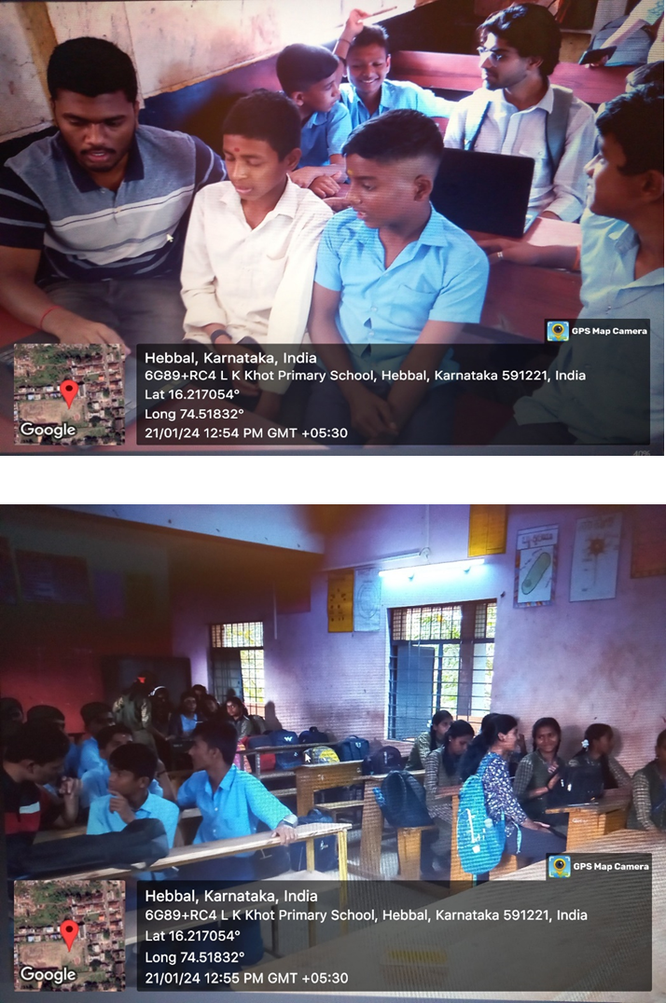

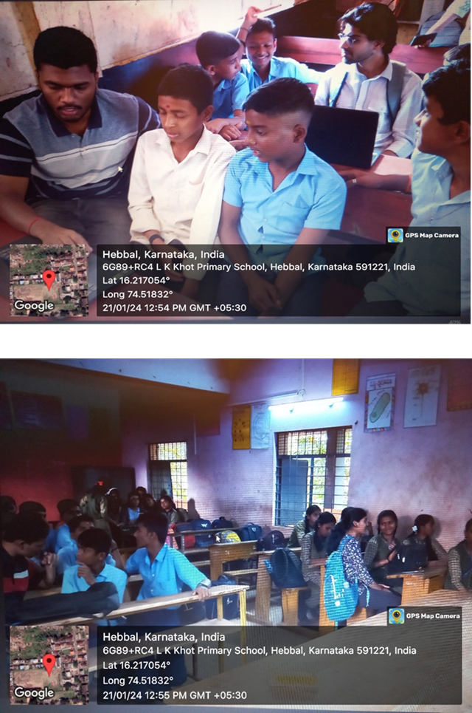

**OVERVIEW OF THE INTERNSHIP**

Following are the concepts I thought to students :

**1. Use of the Internet:**

Internet Safety and Etiquette:

* Explained the importance of creating strong passwords and avoiding sharing personal information online.
* Discussed common internet threats such as phishing scams and ways to identify and prevent them.
* Emphasized the significance of responsible online behavior and good digital citizenship.

Effective Internet Search Techniques:

* Demonstrated how to use search engines efficiently, refining searches with specific keywords and utilizing advanced search operators.
* Guided students on evaluating the credibility of online sources and discerning reliable information from misinformation.

**2. Academic Mathematics:**

Fundamental Concepts:

* Reviewed basic arithmetic operations, including addition, subtraction, multiplication, and division.
* Reinforced understanding of fundamental mathematical concepts such as place value, rounding, and order of operations.
* Introduced concepts of fractions, decimals, and percentages through practical examples.

Problem-Solving Strategies:

* Engaged students in problem-solving scenarios, encouraging them to apply mathematical concepts to real-world situations.
* Introduced various problem-solving strategies, fostering critical thinking and logical reasoning skills.

**3. Use of Microsoft Word and PowerPoint:**

Microsoft Word Basics:

* Provided hands-on training on creating, formatting, and editing documents in Microsoft Word.
* Covered essential features such as font formatting, paragraph alignment, and inserting images.

Creating Presentations with PowerPoint:

* Taught students how to create visually appealing presentations using Microsoft PowerPoint.
* Covered slide layout, text formatting, inserting images and graphics, and incorporating transitions and animations.

**4. Practical Application Exercises:**

Hands-on Activities:

* Conducted practical exercises where students created documents in Microsoft Word, applying formatting techniques learned during the training.
* Encouraged students to explore advanced features in PowerPoint, fostering creativity in presentation design.

Collaborative Projects:

* Facilitated collaborative projects that required students to work in teams, promoting effective communication, cooperation, and sharing of ideas.
* Provided guidance and feedback on the collaborative projects, emphasizing the importance of teamwork.

**5. Continuous Assessment and Feedback:**

Regular Assessments:

* Administered regular quizzes and assessments to gauge students' comprehension of the topics covered.
* Evaluated individual and group performance, adjusting teaching methods based on assessment results.

Individual Feedback Sessions:

Conducted one-on-one feedback sessions to address each student's strengths and areas for improvement.

Offered constructive feedback on assignments, encouraging a growth mindset and a commitment to continuous improvement.

**6. Interactive Learning Environment:**

Engaging Discussions:

* Facilitated discussions on the broader implications of internet literacy, encouraging students to think critically about the impact of their online actions.
* Explored real-world applications of mathematical concepts, fostering a deeper understanding of their relevance.

Q&A Sessions:

* Encouraged students to ask questions and express their thoughts, creating an open and inclusive learning environment.
* Responded to queries, providing additional explanations to ensure a thorough understanding of the topics.

**7. Wrap-up and Recap Sessions:**

Review of Key Concepts:

* Conducted wrap-up sessions at the end of each topic to review key concepts and reinforce learning objectives.
* Encouraged students to ask any remaining questions or seek clarification on challenging concepts.

Reflective Discussions:

Facilitated reflective discussions where students shared their insights and experiences, fostering a sense of ownership in their learning journey.

Encouraged students to reflect on how the skills and knowledge acquired could be applied in their academic and everyday lives.

By meticulously covering these topics and incorporating various teaching strategies, you provided a comprehensive and engaging educational experience for the 6th and 7th standard students, equipping them with practical skills and a deeper understanding of the subjects.

**Skills Acquired :**

Teaching Proficiency: Developed effective teaching methodologies catering to diverse learning styles.Gained proficiency in explaining complex concepts in a clear and understandable manner.

Classroom Management: Acquired skills in maintaining a positive and inclusive learning environment.Developed strategies for managing classroom dynamics and encouraging student participation.

Communication Skills: Enhanced verbal and non-verbal communication skills to engage students effectively.Practiced articulating ideas and instructions in a manner accessible to students of varying comprehension levels.

Technological Competence: Gained proficiency in utilizing educational technology tools for teaching and assessment.Developed skills in integrating software applications like Microsoft Word and PowerPoint into the teaching curriculum.

**Challenges Faced:**

Diverse Learning Needs: Encountered varying levels of academic proficiency among students,requiring personalized approaches to cater to individual learning needs.

Time Management: Managed the limited time available for each session, balancing content delivery with interactive activities and assessments.

Technical Glitches: Faced challenges related to technical glitches during the use of educational technology tools, requiring quick problem-solving to minimize disruptions.

Maintaining Engagement: Worked to sustain student engagement throughout the sessions, especially during theoretical segments, and implemented interactive methods to address this challenge.

Individual Student Attention: Faced the challenge of providing sufficient attention to each student, particularly in a diverse classroom setting, and implemented strategies for addressing individual queries.

**CONCLUSION**

In conclusion, my 28-day internship Shivappanna Gundali Kannada Medium School was a transformative journey marked by significant growth in both my teaching skills and adaptability. The experience allowed me to develop effective teaching methods, foster a positive and inclusive learning environment, and integrate technology seamlessly into the educational process. Navigating challenges, such as language barriers and diverse learning needs, enhanced my problem-solving abilities and communication skills.

Collaborative projects and continuous assessments not only strengthened my ability to work in a team but also improved my capacity to provide constructive feedback. The internship underscored the importance of reflective teaching practices, fueling a commitment to continuous improvement.

Overall, the experience has not only equipped me with valuable skills as an educator but has also deepened my passion for creating engaging and meaningful learning experiences for students. I am grateful for the support of School, the mentorship provided, and the opportunity to contribute to the academic development of 6th and 7th standard students. This internship has been a pivotal chapter in my educational journey, laying a solid foundation for my future endeavors in the field of education.